**Requirement Report**

Café-book Management Software

Development Report

*Team member:*  Nguyễn Việt Nam - 14520560

Trần Trí Nguyên - 14520612

Nguyễn Dương Thảo Linh - 14520465

Nguyễn Minh Trực - 15520936

Contents

1/ INTRODUCTION 1

1.1 Purpose of this document 1

1.2 Product Scope 1

1.3 Glossary 1

1.4 References 1

1.5 Overview 1

2/ System Design 2

2.1 Architecture Design 2

2.2 Database Design 2

3/ GUI Design 3

3.1 Login GUI 3

3.2 Main Screen 3

3.3 Data Working Screen 4

# **1/ INTRODUCTION**

* 1. **Purpose of this document**

The purpose of this document is:

* To state our system design & implementation
* To show the process of our works
  1. **Product Scope**

The product is a software application for computers using Windows operating system and used for people who work at a café-book to manage the store.

* 1. **Glossary**

This subsection contains definitions of all the terms, acronyms, and abbreviations used in the document. Terms and concepts from the application domain are defined.

* Café-book (or book coffee): an establishment which primary serves coffee and books.
  1. **References**
  2. **Overview**

This document contains the following information:

* Provide the system design & implementation description
* Provide GUI design

# **2/ System Design**

* 1. **Architecture Design**

Since the application architecture of our system is a transaction processing system, which is a data-centered application, therefore for the architecture model, we use the 3-layers architecture design pattern which include:

* Data access layer

Objective: Interact between the client system & the database

Tools: We use LinQ (LinQ to SQL) which provide easy & fast database access

* Business logic layer

Objective: Process and transfer data between Data access layer and Presentation layer

The layered structure is divided (based on data characteristics and processing methods) into these sub-layers:

Books

Dishes and drinks

Personal information (including staff and VIP guests)

Schedule

Stocks

Multithreading, customize theme, change language, error handling

* Presentation layer

Objective: Support handling & receiving user requests

Furthermore, we also use some design pattern to help manage, develop, improve & reuse the system more easily

* 1. **Database Design**

For the database design, we use an online database provided by Microsoft Azure to provide data access from anywhere

We also store some various system configuration data in the database to provide flexibility, easier to manage & update

Database is also set with triggers to provide error handling to the user side. We also use trigger to create various data automatically such as order ID, book ID, etc

# **3/ GUI Design**

For the GUI design, we use the Bunifu .Net framework to support our works on GUI design. You could find more information about Bunifu here: <https://bunifu.co.ke/>

* 1. **Login GUI**

When the program starts, the system will require user to log in. User must log in using the username and password given to get access to the system. The login screen will look like this

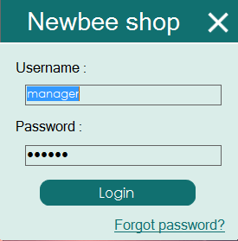

The user will need to provide the username & password to continue

* 1. **Main Screen**

After login to the system, a main screen will be appeared. This will be the main form where the user interacts with the system. The form will look like this:

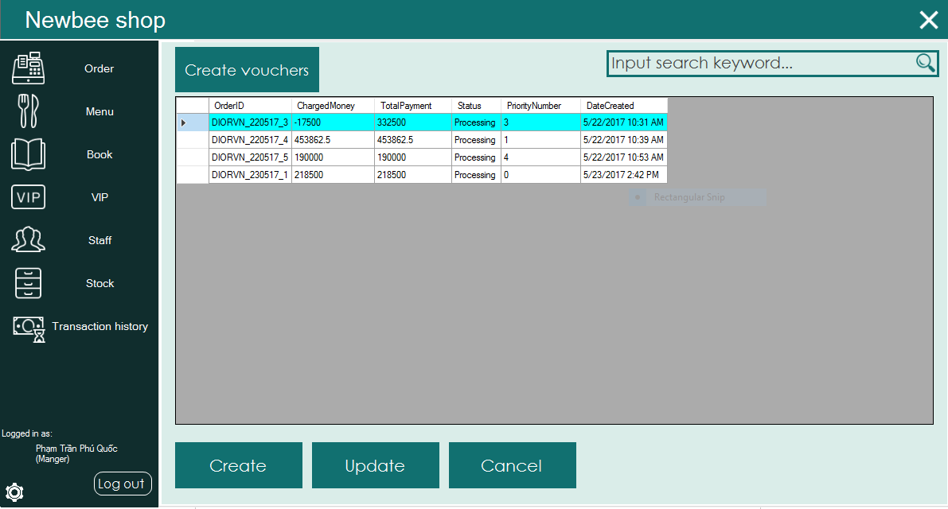

In the left will be the menu tab, where the user chooses what fields he/she wants to works with. Below is the logged in information of a staff. There is also a settings button where the user.

In the middle is the data grid view which will appear the list of object on the system based on the fields he/she chooses to works with

* 1. **Data Working Screen**

The user can click the row header to see the detailed information of the object, The display form varies based on the type of object he/she chooses to view, but the form will be similar to this”

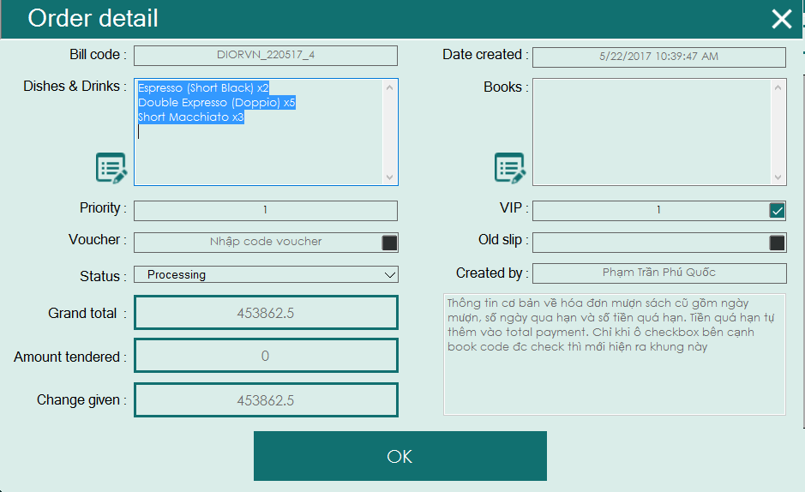

In the view mode, fields will be disabled to indicate that users can’t change values of these field.

In the main form, there are some buttons such as: add, update, delete to allow users to add, update or delete an object in the system. When he/she press the button, a form which is similar to view form will appear, but fields are enabled to allow changing or adding objects. Note that some fields that are generated automatically are disabled to prevent user changes. When he/she confirm, a message will appear to confirm the status of the data

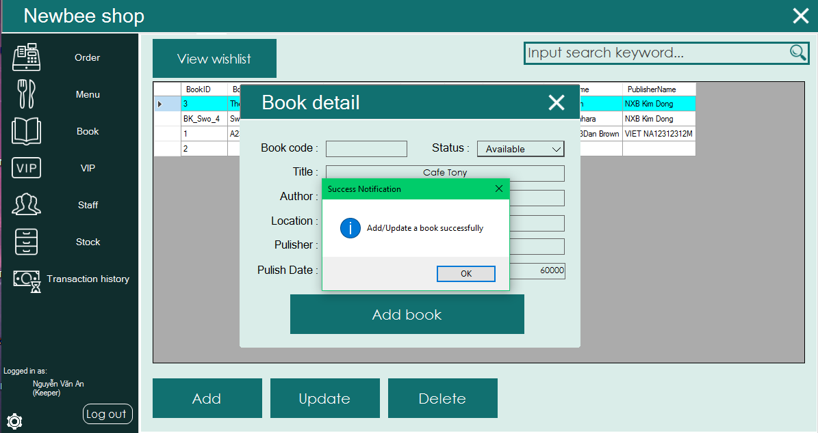

When adding or updating information, a form will appear allow users to choose items:

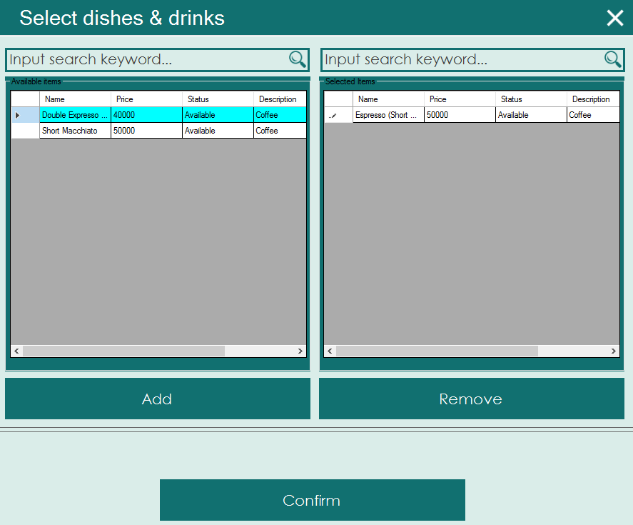

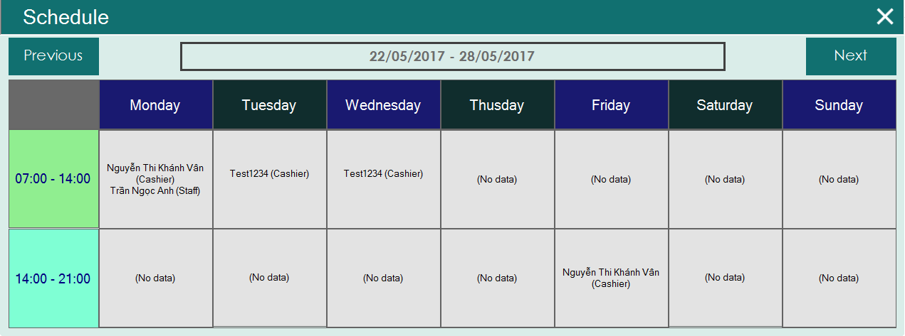 The data grid view in the left is the available items, and the data grid view in the right is the selected items. Users can use the add button to move an item from “Available” to “Selected” & remove button to do otherwise. Sometimes users will need to change quantity of the selected item. He/she will choose the quantity fields & double click to edit. When done, he/she will click “OK” to continue.

This is the schedule form that allow staffs to see the schedule

In the main form, there is a search box in the top right, where you can input data you want to search and press the search icon to search. If the user need to do advance search, he/she will click the search icon without input anything, then an advance search form will appear

In this form the user can input information & press search to search for data he/she wants